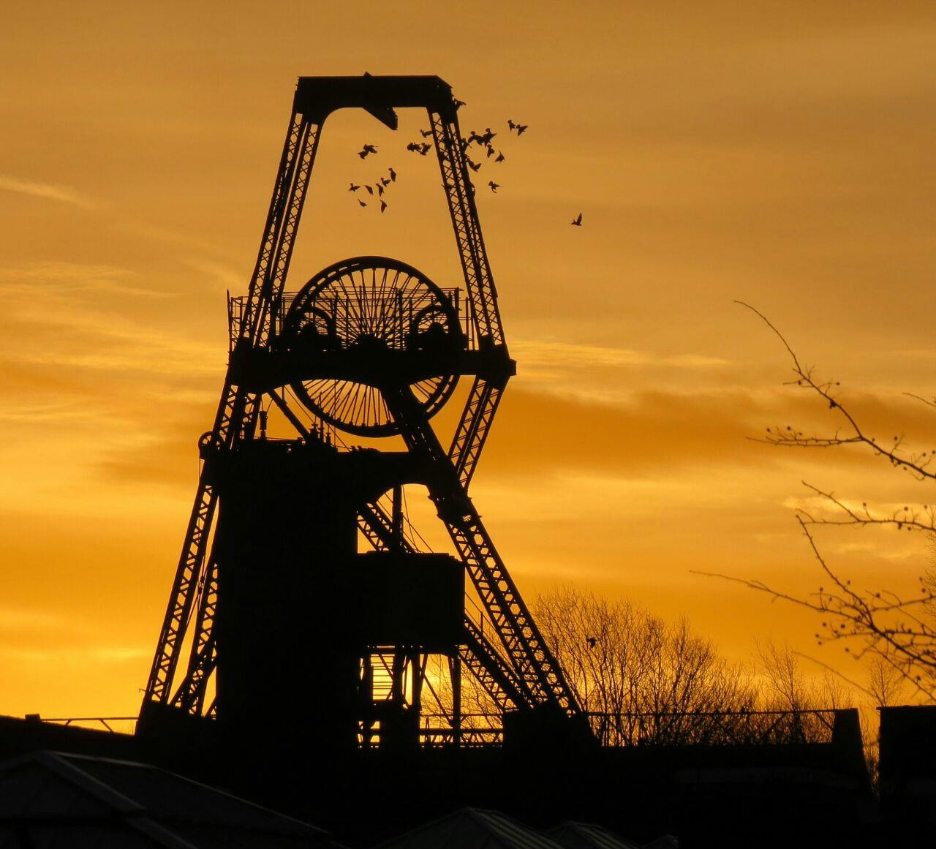

AMANGO’s STRATEGIC REPORT

BY TEAM G-FORCE

HEINRICH VAN DER MERWE JACQUES PRINS
KHANYA XALISILE LLEWELLYN DAVIDS

Introduction 3
Managing divisional performance group-wide 4
Strategic joint venture decision in Canada 5
Revenue 6
Variable cost per Tonne 6
Total variable cost 6
Fixed cost 6
Total cost 6
Break – Even Analysis 7
Profit 7
Recommendation 7
Strategic disposal in Brazil 8
Analysis of Figures 8
SWOT analysis 9
Option 1: Sell AMA-NP 9
Option 2: Do not sell AMA-NP 9
Calculation 9
Recommendation 10
Balance sheet de-leverage 10
Force field analysis 11
Financial ratio analysis 12
Recommendation 12
Operational risk and industrial action in Australia 12
Safety negligence 12
Recommendation 13
Corporate reconstruction and reorganisation 13
Possible subsidiaries to dispose of 14
Calculations 14
Recommendation 14
Conclusion 15

Introduction

The global metals and mining industry is a critical supplier of essential materials, and global generator of trade, employment and economic development. The industry is dedicated to the extraction of metals and minerals for profit and the use in everyday essentials.

AMANGO GROUP MINING PLC is one such multinational organisation that seeks to fulfil this need of man and was one of the world’s top extractors of metals and minerals and was founded more than 100 years ago. With AMANGO’s primary listing on the London Stock Exchange, and a secondary listing on the Johannesburg Stock Exchange(JSE), it boasts with operations in 45 countries and has 160 000 employees.

Although it was once the world’s biggest miner, its current financial state has gradually deteriorated due to the commodity collapse. It became one of the worst performers on the JSE due to borrowings and too many mines that do not generate sufficient profits.

This led to AMANGO creating a 3-year viability statement to dispose of non- core assets, deliver operating cost savings and to reduce the amount of debt. This needs to be taken into consideration when making any crucial decision that will affect AMANGO and their shareholders.

The core values are the foundation of any successful business. This needs to be taken into consideration when:

- Managing divisional performance group-wide
- Strategic joint venture decision in Canada
- Strategic disposal in Brazil
- Balance sheet de-leverage
- Operational risk and industrial action in Australia
- Corporate reconstruction and reorganisation

Managing divisional performance group-wide

The executives acted out of their own mandate, they placed AMANGO in an undesirable position which affected the lives of millions of their workers.

In order to promote operational discipline AMANGO looked at the viability of their current evaluating and rewarding system, since the bonuses of their subsidiary executives are linked to their performances and operating profits.

This action had serious consequences for AMANGO whose business model is based on the seven pillars of value. The critical issue which arose here was the fact that the subsidiary executives, by:

- Postponing standard service schedules for safety critical equipment;
- Retrenched workers from economically viable mines, and;
- Not recorded material financial accounting system, committed unethical behaviour which was in direct violation of the company’s core values as set out in the principals of corporate governance. These executives had no regard for accountability, integrity and collaboration.

Ethical principles and values are crucial to the success of any company, more over to AMANGO which claims that their company’s accountability care and respect. It is a fact that ethical decisions protect the reputation of the business. Investors observe the manner in which a business is managed and if aspects such as fairness, accountability, responsibility and transparency are evident before they invest in such lousiness.

At this stage we can conclude that the behaviour of the executives was far from ethical. Let us now take a deeper look into the consequences of their actions.

By postponing standard service schedules for safety critical equipment, these subsidiary executives not only disregard the Safety and Health (Pillar A), they also placed the miners directly in harm’s way. Safety is an important aspect in the work place and businesses are reliable for the safety of their workers as well as their equipment.

Unsafe work conditions and equipment could lead to devastating consequences, for example loss of life and unproductively. It could also lead to the company not being competitive which in turn means a loss in valuable assets.

Retrenching workers from mines which is still operational and beneficiary are all part of reducing expenses to boost short-term profits. Miners have legal contracts and it’s important for the business to ensure that their rights are taken in consideration and is being respected. We can once again refer back to good ethical behaviour and see that in this case the directors are acting in the benefit of themselves and the company as well as employees will suffer due to bad decision making by directors. This can have an influence on the business’s sustainability in the long run. The retrenching of workers also does not completely correspond with the pillars of the business namely Pillar C (Socio-Political: Partner in the benefits of mining with local communities and government.) In this case workers that have been retrenched do not benefit and neither does the

community. Any business has values and principles that they follow to ensure good practise, but due to greed the directors of AMANGO are making decisions which will influence and reflect negative on the business. It is important to keep in mind that investors and the public look at the values and principles and often based on that decides whenever they will support a business or not. The decisions AMANGO are making now might not only just affect the company’s sustainability in the long run, but also in the short run, because a lot of people could be unhappy and disappointed in the business. Other pillars such as B, D, E, F, and G are also influenced.

The company does not record financial information when required. This behaviour is unethical and does not comply to the king code that represents good ethical practise. This type of behaviour could lead to the end of a business as people will lose all interest in the business. Shareholders are being fed false information on how the business is performing and will have a devastated result. If shareholders should find this out they will most certainly withdraw from the business. It’s also important to keep in mind that this behaviour is illegal and very dangerous for directors to exercise. All this is to lower expenses to boost profits so that the directors get higher bonuses and better share prices for them to exercise options.

In summary, it is obvious that the subsidiary executives of AMANGO acted out of sheer greed to enlarge their bonuses and enrich themselves.

Strategic joint venture decision in Canada

Idle no more, a grassroots aboriginal protest movement in Canada is threatening to cripple the country’s low-risk resource development. Idle no more is pressing for more benefits of mining companies to accrue to original native Canadians. A new trend has been noted with competitors setting up joint ventures with local partners, mostly members of Idle no more.

AMANGO also wants to sink their mining infrastructure into the ground but is not sure of which design to use between Design 1, Design 2 or Design 3 as they are worried about the coal demand.

AMANGO should consider partnering with ‘Idle No More ‘not only because of continues pressure by this aboriginal protest movement but also because as stated in their pillars, pillar C, it has a responsibility to partner with local communities and governments for the benefit of the Canadians in this case.

Mining is a source of tax revenue and driver of the economy as it is used by the government to obtain resources for national development. If AMANGO does not partner with “Idle No More” They would be considered as unfair and unethical by lacking integrity as they would have violated their pillar C.

The king code III States that as an Ethical leadership “the board should provide effective leadership base on an Ethical Foundation”. It elaborates on this principle by adding that leaders should consider the impact of the company’s strategies and operations on the economy, society and environment.

This means if AMANGO does not partner with “Idle No More” and continues with their reputation for low – risk resource development they would be going against this principle. In the corporate citizenship principle King III also stipulates that the board should consider not only financial performance but also the impact of the company’s operations on the society and the environment.

Revenue

5 million tonnes x $50, 24 = $251, 2 million

7, 5 million Tonnes x $50, 24 = $376, 8 million 10 million Tonnes x $50, 24 = $502, 4 million

Variable cost per Tonne

Minimum – $26, 38 x 1 = 26, 38

Median – $26, 38 x 1, 35 = 35, 613

Maximum – $26, 38 x 1, 50 = 39, 57

Total variable cost

Minimum – 26, 38 x 5million tonnes = $131 900 000

Median – 35, 613 x 7, 5 million tonnes = $267 097 000

Maximum – 39, 57 x 10 million tonnes = $395 700 000

Fixed cost

Minimum – $75 million Median – $87.5 million Maximum – $100 million

Total cost

Minimum – $131 900 000 + $75 000 000 = $206 900 000

Median – $267 097 500 + $87 500 000 = $354 597 500

Maximum – $395 700 000 + $100 000 000 = $495 700 000

Break – Even Analysis

Minimum: $75 million

50.24-26.38

=3 143 337 units Median: $87.5 million
50.24-35.613

=5 982 088 units Maximum: $100 million
50.24-39.57

=9 372 071 units

Profit

Minimum: [$251.2 million-(3 143 337 x $50.24)]

=$93 278 749.12

Median: [$376.8 million - (5 982 088 x $50.24)]

=$76 259 898.88

Maximum: [$502.4 million-(9 372 071 x $50.24)]

=$31 547 152.96

Recommendation

AMANGO should make one of the Idle No More members one of their directors to make them more inclusive in their 50/50 joint venture with Cephas.

AMANGO should use Design 1 as it is the most convenient design out of the three and the most profitable.

Strategic disposal in Brazil

AMANGO received a final offer of $750 million from CMOC for AMA-NP, one of their subsidiaries based in Brazil. They now have to decide whether they are going to accept or deny this offer.

AMANGO makes it very clear that they are seeking to dispose of assets and or subsidiaries. This is especially emphasised in a statement issued by the CEO of the company which stipulates that they are seeking to raise an amount of 2-3 Billion US$ from asset disposals in 2017. This is why it is so important that the company considers this offer from CMOC and make a strategically decision that will only benefit AMANGO and its shareholders.

Factors that needs to be taken into consideration when making this decision:

- 7 Pillars which the company (AMANGO) base its values on
- Risk Management of the company
- 3 Year viability statement set up by AMANGO 3-year viability statement
This strategy consists of 3 major objectives namely:

  - Radical portfolio reconstruction which mainly consists of the disposal of non-core assets of the business.
  - Drive operational discipline that targets to deliver operating cost savings of R5.8 Billion.
  - Protect the balance sheet which targets a Net Debt of R10 Billion by the end of 2017.

Analysis of Figures

All figures given in Brazilian Real (BRL) needs to be converted into USD as this is the overall currency used by AMANGO. By using foreign exchange rates these values can by calculated by using the following calculation:

Amount given in Brazilian Real × Current exchange rate of BRL/US$ (0.31)

Sector Price to earnings (P/E) Ratio | $4 030 000
Non-current assets | $593 650 000
Earnings (Profit after tax ) | $34 100 000
Net current assets | $240 250 000
Long-term debt | $83 700 000
Total long-term debt +Equity | $833 900 000
Operating Profit (EBIT) | $48 670 000

SWOT analysis

A SWOT analysis of AMA-NP is done to distinguish between their strengths, weaknesses, opportunities and threats.

Strengths | AMA-NP is  generating a profit. of $34 100 00. | Weaknesses | AMA-NP has a long-term debt of  $83 700 00.
Opportunities | Competition  amongst other mining companies will decrease because they are also seeking to dispose of assets. | Threats | Face the threat of  being sold by AMANGO as part of their turnaround strategy

Analysis op options

Option 1: Sell AMA-NP

Firstly, taking into consideration that the business seeks to raise an amount of 2-3 billion US$ in 2017 from disposals. The offer of $750 million will cover an average percentage of 30% of the amount that the business is seeking to accumulate on this one deal alone.

Average percentage covered: $750 000 000 ÷ $2 500 000 000 × 100 = 30%

Analysing debt values of AMA-NP

AMA-NP has an amount of $83 700 000 in long term debt owed. Eliminating this debt would comply with point 3 of the turnaround strategy in reducing the company’s debt to a net value of R10 Billion by the end of 2017.

Option 2: Do not sell AMA-NP

The offer received from CMOC of $750 000 000 is not reflecting the true value of AMA- NP. Looking at the figures in the table above it is seen that AMA-NP has a long-term debt of
$83 700 000 and a Long-term debt + Equity of $833 900 000. The equity value can be
calculated as follows:

Calculation

Equity = (Long-term debt + Equity) - (Long-term debt).

$833 900 000 -$83 700 000 =$750 200 000.

Thus the equity value of AMA-NP is $750 200 000, $200 000 more than the offer of CMOC. The equity value is also known as the Net Asset Value of the business, because this figure is higher

than the offer made by CMOC, selling the business at a value lower than its Net Asset Value would not deliver appropriate value for the investors as the equity value is a key figure on which the value of the business is based on (pillar G).

Risk level of AMA-NP

AMA-NP has an operating profit of $48 670 000 as well as a profit after tax of $34 100 000 as provided in the table above. Thus selling of a profitable business would be considered as unwise, considering the offer made is lower than the Net Asset Value of the business itself. (Not high risk)

Summary of options

Option 1: Sell AMA-NP on the basis that it complies with points 1 and 3 of the 3-year viability statement.

Option 2: Do not sell AMA-NP on the basis that it does not comply with pillar G of the mission, values and business model, as well as it does not have high risk associated with it because it is generating profits.

Recommendation

It is strongly recommended that AMANGO does not dispose of AMA-NP for a value of
$750 000 000 because it is generating a profit and this deal would go against business policies in terms of returning sustainable profits towards investors. Losing investor confidence is one thing AMANGO cannot afford at this stage, completing this deal would definitely give investors reason not to have any confidence in AMANGO at all.

Balance sheet de-leverage

South Africa’s Public Investment Corporation (PIC) is challenging AMANGO’s plans to dispose of its coal and iron ore subsidiaries in South Africa. If the PIC does not get its way and the sales of these subsidiaries proceed, it plans with a few other investors, to start dumping the shares of AMANGO on the market by the end of 2017. The PIC is an investment manager. They manage assets of over R1, 857 trillion.

They threatened to dump more than 15% of AMANGO’s shares if they sell their coal and iron ore subsidiaries in South Africa. This will have a huge negative impact on AMANGO’s share price. This will have an effect on the bonuses of directors and on returns to shareholders. This collides with one of AMANGO’s key priorities (pillar G).

Kurt Lewin's force field analysis technique has been used to distinctively identify the forces at play when deciding which option will be the best for AMANGO.

Force field analysis

Figure 1: force field analysis of selling subsidiaries (coal and iron ore)

Selling of subsidiaries

The company will get rid of 3
unprofitable mines
4 The PIC will dump shares

No further harm will be done 3
to the environment by these mines(pillar B)
4 More than 36000 people will lose their jobs in South Africa

6 8

The disposing of these subsidiaries would have the effect of 36000 people losing their jobs in South Africa. This will contribute to South Africa’s unemployment rate that currently stands at 26, 6%. This also collides with one of South Africa’s macroeconomic objectives of full employment.

By analysing the force field analysis, it is clear that the selling of the subsidiaries has a more negative impact on AMANGO.

AMANGO is considering an alternative proposal, by not disposing of the coal and iron ore subsidiaries in South Africa, they plan to sell a section of their property portfolio. They are planning to sell 71% of their apartments to Black Economic Empowerment Properties. This will contribute to the mining law and charter mooted by the South African government that requires AMANGO to release 16% of their companies to Black South Africans.

Figure 2: force field analysis of selling a part of property portfolio

Selling of property
The PIC will not dump shares 4 4 AMANGO would lose
these assets

The workers in South Africa 4
will retain their jobs
2 The rental income from the workers would be lost

The property will be sold to a 3
BEE company
The workers that lease 2
these apartments would still live there.
13 6

If AMANGO goes through with the selling of the property, they will generate $6, 40065 billion on the book value; with property market value always higher than the book value, AMANGO can expect to make a higher profit when selling the property.
Financial ratio analysis

Before the sale, the debt: equity ratio is 1, 16: 1($24815000000: $21342000000 meaning that the whole of the company is high geared and high risk. The company relies more on foreign capital. Which results in higher interest payments?

If the sale goes through and AMANGO uses the money they generate from the sale to pay down debt, the ratio will then be 0, 86: 1. This means that they are still fairly high geared but it decreased with 0, 3.

Recommendation

Figure 2 clearly indicates that it is in the best interest of AMANGO to sell a part of their property portfolio. This decision will reduce the total amount of debt that AMANGO owns and that 36000 people would retain their jobs.

Operational risk and industrial action in Australia

A controlled shut down has been hurriedly effected in one of the group’s mines in Australia with 560 personnel evacuated due to safety concerns, 6 are reported dead and 80 miners have been trapped, all this due to a newly constructed mine shaft that failed in its first week in operation due to faulty geotechnical design; causing a near collapse of the mineshaft. The first important aspect that arose is who is responsible for this and how did this happens.

Safety negligence

The initial inquiries reveal consistent over delivery on production targets which unions attribute to excessive overtime. Once again unethical behaviour arises again as where 10 deaths in 2016 were not reported. This type of behaviour is totally unacceptable. Experts have warned that any attempt to resume production at the faulty mine shaft without fully detecting and addressing the problem could cause a total collapse – dealing a fatal blow to safety. Referring back to pillar A (Safety and Health) the CEO Mike Cutika has ordered that the mine shaft be re-opened for production to resume while it has been brought under his attention what the result of this could be. Instead of reopening the mine a group of specialists should have examined the mine first to take all necessary steps to insure the safety and health of the miners. This was bad decision making by the CEO Mike Cutika. Mike Cutika was more concerned about the US$250 000 that they were losing every day the mine was closed, then the safety and health of the miners.

now threatening strike action in 7 days unless serious action was taken to confirm the group’s commitment to safety. The business should have implemented any protective measures that may be necessary to reduce the risk of harm cause in the workplace. A SMS (Safety

Management System) should be implemented. Safety management is managing business activities and applying principles, framework, processes to help prevent accidents, injuries and to minimise other risk. Miners belong to unions to protect them in cases such as these. The safety of the miners should at all-time come first and must not under any circumstances ever be put second.
Re-opening the mine shaft and attempting to resume production would mean bringing harm to the work force and a violation of pillar A, of the pillars of value.

The professional bodies of the engineers who designed the shaft systems should also be held responsible for the collapse as they failed to perform their role of making sure that engineers were suitably qualified and skilled to create the systems.

The ethical and individuals to:

- Be accountable for their actions.
- Perform and report on their duties in a transparent manner.
- Carry out their duties in a sustainable manner that does not compromise the economic, environmental and social well-being of others.

Recommendation

AMANGO should continue keeping the mine closed until they address the problem to avoid any damage or danger to the miner’s lives. The mine should be inspected by a group of specialists to ensure that mine are safe. The company must set a time frame to avoid any unnecessary expenses since the company loses $250000 each day the mine is closed. It would be wise for the business to move into a shutdown protocol to limit expenses and use the time on hand effectively to come up with the best way to overcome this obstacle.

Corporate reconstruction and reorganisation

AMANGO is faced with the challenge of selling subsidiaries as part their turnaround plan. They hope to raise an amount of $2- 3 billion by doing so. This was scrutinised by the PIC. A statement issued by the CEO of the PIC states that they will only invest in and support companies that do not only deliver superior shareholder return but care deeply about the socio- economic needs of South Africa.

The PIC holds a 15% stake in AMANGO and thus has a large influence on the company. Selling any subsidiaries in South Africa would contribute to the high unemployment rate of the country currently on 26, 6%. This does not comply with the policies of the PIC in terms of contributing to the country’s socio- economic needs. This needs to be taken into consideration when disposing of any subsidiaries.

Possible subsidiaries to dispose of

Nickel limited is the only subsidiary AMANGO should consider selling, based on the following calculations:

Calculations

Market share %:

(Revenue of AMANGO in Nickel LTD ÷ Total sales of Nickel LTD) ×100 ($146 million ÷ $3650 million) × 100
=4%

Decrease in Operating profits %: (figures of Nickel LTD only)

(Difference in operating profits from 2015-2016 ÷ operating profits 2015) ×100 ($21 million – (-$22 million) ÷ ($21 million)) × 100
$43 million ÷ $21million

=204.76%

Operating profit over revenue %:

(Operating profit 2016 of Nickel LTD ÷ Revenue 2016 of Nickel LTD) × 100 (-$22 million ÷ $146 million) × 100
= -15.07%

Recommendation

Although Nickel LTD boasts a market share of 4% world-wide, it’s operating profits decreased with 204.76% from 2015 to 2016.It also has an operating profit over revenue % of -15.07% in 2016. By taking these figures into consideration it is very clear that AMANGO should consider selling Nickel LTD on one condition, that it is not based in South Africa.

Conclusion

In conclusion it is found that:

- AMANGO is largely influenced by other companies and organisations for instance the PIC and Idle no more as seen above.
- AMANGO is highly geared with debt to equity ratio of 1,16: 1, which is very bad and indicates that the business has n debt problem.
- Due to the debt problem the directors of AMANGO are taking unethical decisions to boost short-term profits in a quest to increase their bonuses.

It is strongly recommended that AMANGO should consider selling a part of their property portfolio to Black Economic Empowerment Properties. They should consider selling unprofitable mines to raise capital for the settling of debt and focus more on mines that are generating profits instead.

