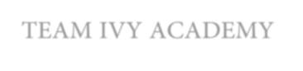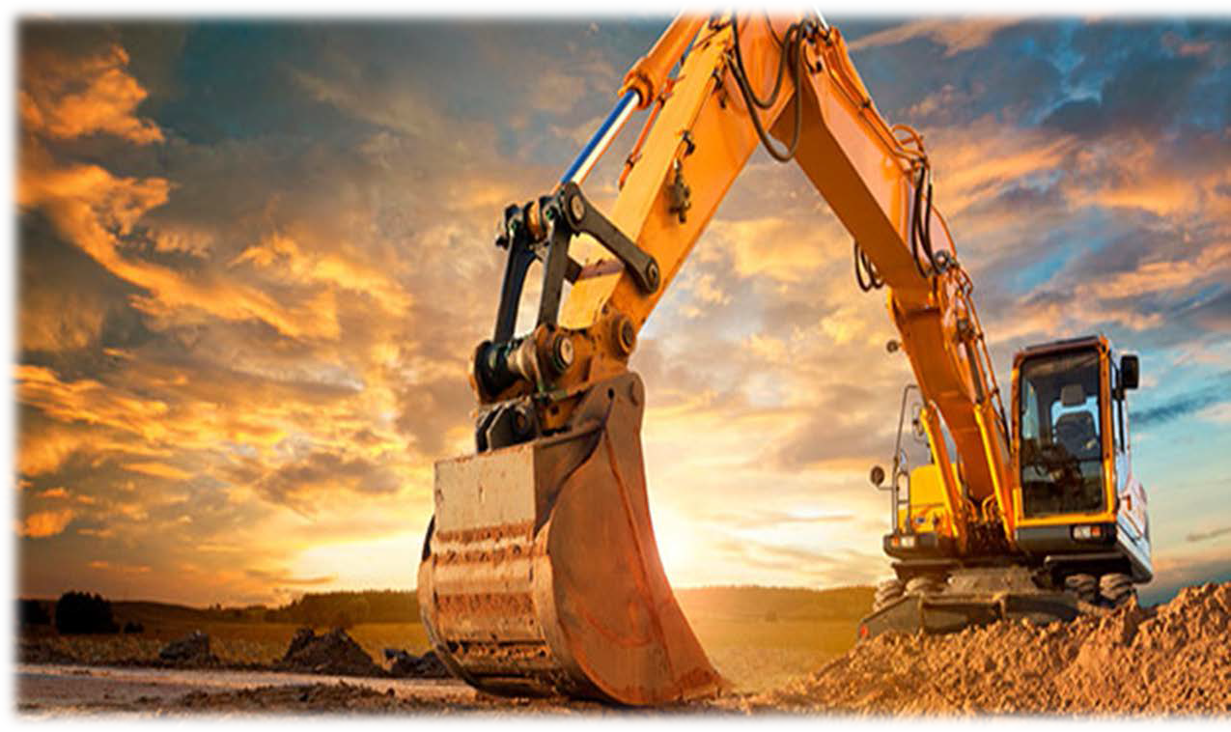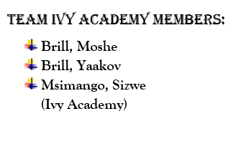

TEAM IVY ACADEMY

INDEX

INTRODUCTION……………………………………………………………………………………………………………………………………………………………..PAGE 2

PRIORITIZATION………………………………………………………………………………………………………………………………………………………….…PAGE 3

PROBLEM/ISSUE: MANAGING DIVISIONAL PERFORMANCE GROUP-WIDE

 Overview……………………………………………………………………………………………………………………………………..………………..PAGE 4
- POSTPONING STANDARD SERVICE SCHEDULES FOR SAFETY CRITICAL EQUIPMENT……………………………………..PAGE 4-5
- RETRENCHMENT OF WORKERS EVEN FROM MINES THAT ARE ECONOMICALLY VIABLe……………………...........PAGE 5
- NOT RECORDING MATERIAL FINANCIAL TRANSACTIONS……………………………………………………..……….................PAGE 5-6

OPERATIONAL RISK AND INDUSTRIAL ACTION IN AUSTRALIA

❖ | Overview……………………………………………………………………………………………………………………………………………………….PAGE | 6
❖ | Force-field analysis, challenges and solutions………………………………………………………………………………………………..PAGE | 7-9

CORPORATE RECONSTRUCTION AND RE-ORGANIZATION

 Overview…………………………………………………………………………………………………………………………………………………….…PAGE 9
 Challenges and solutions……………………………………………………………………………………………………………………….………PAGE 9-10

STRATEGIC JOINT VETURE(JV) DECISION IN CANADA

 Overview……………………………………………………………………………………………………………………………………………………...PAGE 10
 Challenge and solutions……………………………………………………………………………………………………………………….………PAGE 10-11

STRATEGIC DISPOSAL IN BRAZIL

❖ | Overview………………………………………………………………………………………………………………………………………………………PAGE | 12
❖ | Challenges and solutions………………………………………………………………………………………………………………………,…….PAGE | 12

BALANCE SHEET DE-LEVERAGE

 Overview………………………………………………………………………………………………………………………………………………………PAGE 12
 Challenges and solutions………………………………………………………………………………………………………………………………PAGE 12-13

AMANGO’S S.W.O.T ANALYSIS……………………………………………………………………………………………………………………………………PAGE 14

Introduction

“Mining is the extraction of valuable minerals or other geological materials from the earth usually from an orebody, lode, vein, seam, reef or placer deposits. These deposits form a mineralized package that is of economic interest to the miner.”

Mining is the second of humankind’s earliest endeavors. It supplies all the basic resources used by modern civilization. It has great advantages as it brings about economic growth, employment (job creation) and reduces various number of socio-economic issues.

However, mining operations usually create a negative environmental impact hence most governments, which typically are the custodians of mining rights and operating licenses, have passed regulations to decrease the environmental impact, including furthering other socio-economic interests such as job creation, tax revenues, infrastructure development and economic empowerment. Health and Safety have long been a concern, and indeed, together with the environment, ability to raise finance and cost competitiveness, are amongst the critical success factors in the industry.

The mining sector is a diverse market with huge prospects attached to it but it takes sound ethics to strive in this sector, apart from the large sums of capital that are required to invest and realize the enormous potential.

AMANGO engages in exploring, mining, processing and smelting Precious Metals, Base Metals and Bulk Commodities. Precious Metals are classification as metals that are rare and/or have a high economic value. The group’s mission is to deliver returns to its global base of shareholders, working with key stakeholders to create sustainable value that makes a real difference; guided by the core values of safety, innovation, accountability, care and respect, integrity and collaboration. To achieve this mandate, the group has fully subscribed to the principles of corporate governance and integrated reporting, expressing its basic business model and key priorities into 7 Pillars of Value. (As further depicted in ‘Prioritization’ pg. 3)

However just as expected in the business world, challenges will always be prevalent despite the size of the business. In face the bigger the business the bigger the challenges. Businesses need to adapt and change to meet the challenges and remain profitable.

Prioritization

“AMANGO’s mission is to deliver returns to its global base of shareholders, working with key stakeholders to create sustainable value that makes a real difference; guided by the core values of safety, innovation, accountability, care and respect, integrity and collaboration. To achieve this mandate, the group has fully subscribed to the principles of corporate governance and integrated reporting, expressing its basic business model and key priorities into 7 Pillars of value:”

- Pillar A: Safety and Health: Do no harm to the workforce.
- Pillar B: Environment: Minimize harm to the environment.
- Pillar C: Socio-Political: Partner in the benefits of mining with local communities and government.
- Pillar D: People: Resource the organization with an engaged and productive workforce.
- Pillar E: Production: Mine, move, extract and process ore reserves sustainably.
- Pillar F: Cost: Be competitive by operating as efficiently as possible.
- Pillar G: Financial: Deliver sustainable returns to shareholders.

From this data, we can rank AMANGO’s issues from the most critical to the critical pillar.

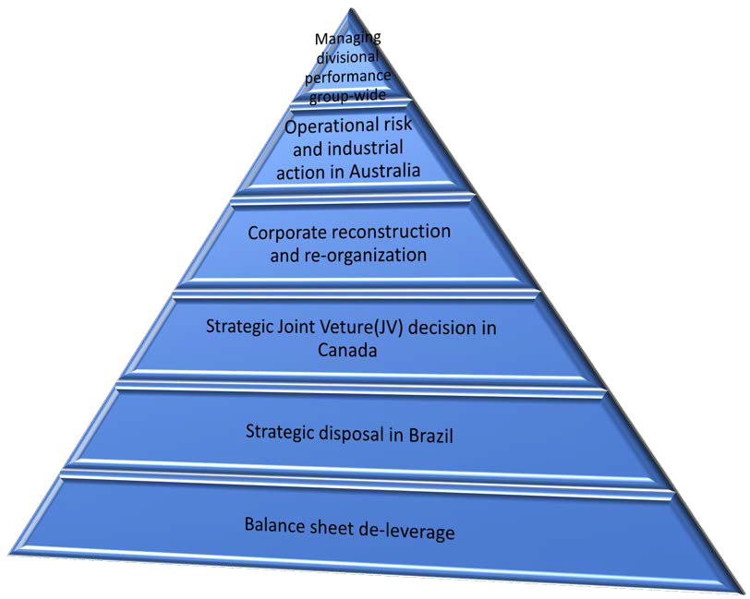

Managing divisional performance group-wide

To maintain commitment from its executives, AMANGO has decided to reward their executives with bonuses. In doing so, they are trying to motivate and inspire the executives to reach high standards of excellence, as part of the strategic management in the micro-environment. However, AMANGO is doing so in vain as the subordinate executives are becoming too complacent, losing ethics and business morals and are neglecting the core business goals.

Postponing standard service schedules for safety critical equipment:

AMANGO’s subsidiary executives delay standard service. This is the service that clients, investors and day- to-day consumers are entitled to. Safety critical equipment is a vital aspect to focus on because it is a system that if it fails, could cause or contribute to a major accident. Its purpose should also be to prevent or mitigate the impact of accidents.

By focusing on the SCE, AMANGO can ensure that the safety barriers are in place and effective, in alignment with the specific performance standards, which is of great benefit to the company. As much as this is in the best interests of the company and its clients, it does not mean that customer service should be neglected because neglecting customer service is one operational risk that could be highly detrimental to the business. This neglect could lead to issues such as:

- Loss of customers.
- Low productivity rates leading to a loss of investors.
- AMANGO’s reputation can be tarnished through customers’ service reviews on the net or by word of mouth.

These problems can harm AMANGO and may result in loss and ultimately a shutdown.

Safety critical equipment, amongst other things ensures safety in the workplace and assists the business in complying with COIDA ACT. However too much reactive focus on this is not wise for the business, which is why a solution should be found to prevent, the issues listed above from occurring.

Solutions:

AMANGO has been injecting their profits into the subsidiary executives and not into the neglected customer service, which affects the main objective of the business, which is making profit. However, this can have resolved:

- AMANGO should divide the money that they are giving away as “rewards” to the executives; cut down on the bonuses and employ more executives to focus on the standard service of the business and use those intended bonuses to pay the newly employed personnel.
- AMANGO should put the word out there that one of their major projects is to put effort into safety critical equipment in the interests of their customers, which will make customers feel that AMANGO is not completely neglecting them. AMANGO needs to enhance their image of being a company that bears the customers’ interests in mind to keep customers content and instil loyalty.

When it comes to the operational side of a business, customer service is in fact one area that companies cannot afford to overlook. A survey by CRM Today showed that roughly half of the consumers in the UK and the US have switched to a competitor due to poor service. Secondly, the reality in the digital age is that social media and other forms of communication make negative customer experience very visible and evident, not just to other customers, but to prospects. Companies clearly should avoid this operational risk at all costs. By ensuring that AMANGO puts this into practice, the success of AMANGO is guaranteed.

Retrenchment of workers even from mines that are economically viable:

Since AMANGO has been giving capital to those executives in the form of bonuses, it means that the executives get to have their pockets greatly enlarged. This seems to have turned the executives into a greedy panel, as they know that by retrenching workers more money gets to come to them and they benefit greatly from that which shows a lack of integrity in the workplace.

Retrenching workers from mines that are economically viable poses issues such:

- Labor disputes between workers’ trade unions, which will cost the business money due to the court cases that they may have to attend to.
- Industrial actions by retrenched workers.
- More internal problems like salary increment demands by the workers that have not been laid off.
- Retrenched workers may go to the media with bad reviews about AMANGO, which will lead to bad publicity therefore investor loss of confidence.

Solutions:

- AMANGO should sit down and negotiate with its employees. AMANGO should tell its employees that they are considering retrenching workers but they are willing to reach a consensus if the workers agree on salary decrements.
- AMANGO should avoid union disputes and public scandals by not considering retrenchment unless it is unavoidable.

Not recording material financial transactions into the online financial accounting system:

Since executives have been receiving bonuses, they have, however not reached the level of expectations demanded by management. They are not recording transactions in the online system.

This is impacting on the business in a negative manner, as AMANGO will be unable to identify the accurate financial status of the business. This is extremely dangerous for the business, as debtors become hard to identify. Not recording the transactions of AMANGO, will also result in stress, as the value of the assets (debtors) will be misleading and decisions which will be made will cause confusion, (incorrect calculations). This will lead to bad internal control and ultimately lead to low profits and at the worst insolvency.

AMANGO must restore its internal control:

- AMANGO should ensure that all transactions are recorded on the system by recruiting an external financial auditor to audit their financial records and ensure that all recorded transactions are accurate.

AMANGO will then be able to pay their employees a higher salary, including bonuses, if all transactions are maintained well enough. One last resort AMANGO could resort to is dismissing their management team or executives as they are not portraying the ethics and morals that every professional should uphold.

Operational risk and industrial action in Australia

In summary, AMANGO is in an enormous dilemma: AMANGO has newly established another mine in Australia, which unfortunately failed to operate within the first week due to poor geotechnical design which almost lead to a total collapse of the shaft. Due to this, the subordinate CEO ordered an immediate shutdown of the mine to save the workers from injuries or even worse, death.

Problems posed by this subject:

- Shutdown of one of AMANGO’s mines in Australia leading to US$250,000 daily capital losses.
- Six reported deaths which threaten to tarnish AMANGO’s reputation.
- Shaft systems’ failure due to faulty geotechnical design, causing a near geotechnical disaster in the mineshaft.
- Unions’ disputes and uncertainty about their members’ safety (injuries and fatalities, including over 10 deaths in 2016 which were not reported) and workload (excessive overtime). This also threatens AMANGO’s image and creates possible lawsuits against AMANGO.

Resolution:

AMANGO should engage in creative thinking, the ability to think innovatively. Creative thinking will easily allow AMANGO to apply problem solving in resolving the issues that they are faced with. AMANGO now should critically evaluate possible solutions pre-selecting a viable solution.

AMANGO is in a huge predicament therefore it cannot make hasty decisions because such decisions will have maximum, crippling impacts on the company if they fail. AMANGO may use techniques such as mind-mapping, empty chair, Delphi, forced combinations or brainstorming. Despite these being time- effective, they are not feasible enough to unravel the issues that AMANGO is currently facing. Therefore, we need a technique that will give AMANGO sure results.

There are two suggestions, (Experts of Mining Design and CEO, Mike Cutika’s) one of which AMANGO can use as a solution. We must weigh the pros and cons of both possible solutions and choose the one that out-weighs the other. Therefore, the most viable problem solving technique AMANGO can use here is the ‘Force-field analysis’.

APPLYING KURT LEWIN’S TECHNIQUE:

(Experts suggestion) Stop AMANGO’s operations: detect and address causes of total collapse:

AMANGO has been doing consistent over delivery on production. They have possibly made a surplus and can
  - therefore use the surplus for a
maximum of two years to fix the isses:
re-assuring investors, negotiating with
unions and fixing the geotechncal
deign errors.

Will save company from having to re-
  - construct the mine shaft from scratch if
those errors are addresses during
company shutdown.
3 Will keep unions quiet

While workers are off-duty, they will see that they need a job and thus will be
4 motivated to work once the mine is re-
opened - even if it means stopping industrial
action.

3

Investors may feel like AMANGO are
1 not risk-takers or problem-solvers and
therefore disinvest from AMANGO

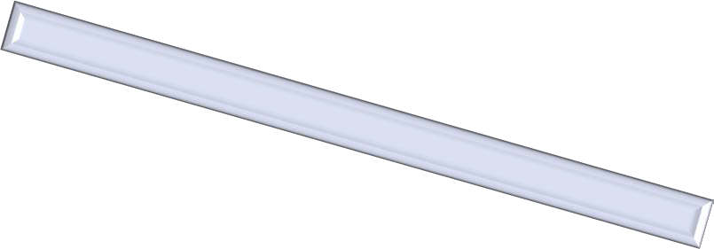

16 pts

12 pts

(Mr. Cutika’s order) Continue AMANGO’s operations:

- AMANGO can coninue to make its daily capital of US$180,500.000
The minshaft is near a complete collapse and that can lead to a total destruction
- of the mine which will be more costly to
re-build

Investors that hear about the experts'
4 conclusion on the matter may disinvest
in AMANGO

3 Unions will not allow their workers to
work in hazardous working conditions
and may therefore demand higher
4
salaries for their members which will
cost the business.

2
13 pts

9 pts

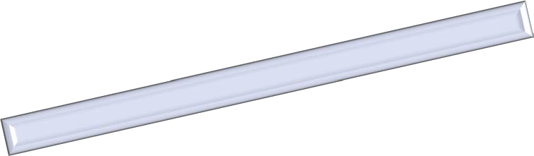After conducting the two Force-field analyses we can draw up a conclusion:

The experts’ opinions outweigh all other factors that come into play, including the CEO order to continue operating the mine.

What does it mean if AMANGO considers the experts’ opinions (IMPACTS)? Disadvantages:
- AMANGO will be making a more than US$180,000,000 loss of capital within the minimum two years of fixing the geotechnical errors.
- AMANGO will lose some investors during the course as investors cannot keep their investments where they will not accumulate.

- AMANGO may have to spend more money to fix the errors, assure investors and negotiate with unions.
- The media can toil and tarnish the brand with speculations as to why AMANGO shut down. Advantages:
- AMANGO can save itself from a scandal of being responsible for more deaths and injuries of workers when the mineshaft finally collapses as predicted by experts.
- AMANGO’s shutdown for two years will give AMANGO ample time to reinforce the mine’s geotechnical areas.
- AMANGO can come back stronger, with a safer working environment thereby showing compliance with the COIDA ACT.
- AMANGO will be saved from law disputes with trade unions.
- AMANGO will have a large pool of potential employees to choose from once it re-launces What does it mean if AMANGO considers the CEO’s decision (resuming operations)? Advantages:
- AMANGO will not suffer US$250,000 daily losses in capital.
- AMANGO will be able to keep investors happy. Disadvantages:
- All the advantages eventually turn out to be negatives in the long run.
- The mine will eventually collapse within a period of months and this will lead to a loss of employees, assets and the business image.
- Investors will immediately disinvest from AMANGO.
- AMANGO may be fined for non-compliance with COIDA ACT.

Clearly the CEO’s decision is not a viable option as it leads to the destruction of the business. The best solution to take emerges from the experts’ opinions.

CORPORATE RECONSTRUCTION AND RE-ORGANIZATION

The PIC (Public Investment Corporation) of South Africa is questioning AMANGO once more. They claim that AMANGO sells their assets too frequently. They also prefer to invest in a company that tries to help their citizens and cares about the development of South Africa.

The PIC threatens that they will not be investing in a company who disinvests in its country.

AMANGO are faced with a challenge. On the one hand, they need to sell their assets to recover their long- term debt. On the other hand, PIC needs to ensure they gain a profit from their shares. Thus, AMANGO cannot sell all their assets to non-South African entities.

US$ millions | Coal Limited | Nickel Limited | Platinum Limited | Diamonds Limited | Copper Limited | Nobium  Phosphates Limited | Iron Ore and  Manganese Limited
Current sales | 97760 | 3650 | 12564 | 13738 | 39322 | 27200 | 37667
Sales in the next 10 years | 134864 | 20075 | 41661,2 | 71437,6 | 165152,4 | 130560 | 244835,5

As we can see from this diagram, in the next 10 years Nickel Limited, Platinum Limited and Diamonds Limited will be earning the least. Cleverly, AMANGA should sell these companies to South African citizens to keep both PIC and the South African households happy.

If AMANGO sells Coal Limited, Copper Limited, Niobium Phosphates Limited, Iron Ore and Manganese Limited, in the next 10 there will be a happy county.

Strategic Joint Venture (JV) decision in Canada

Coal trading has increased by US$ 37,24 per tonne. This leads to the following issues that AMANGO are faced with:

- Difficulties in finding enough financial resources to spend on coal
- Shortage in quantity demanded for coal as it is demanded on the minimum level
- Decrease in sales because of less demand
- Lack in ability to pay for the largest construction that costs US$ 100 000
- Coal demand levels are unstable and unreliable

AMANGO must study the figures provided in the table below, so that they can prepare for the future.

CHANGES IN COAL COSTS AND DEMAND

DEMAND LEVEL | COST PER TONNE  ($) | INCREASE PER TONNE (%) | INCREASE PER TONNE  ($) | QUANTITY DEMANDED (MILLIONS) | QUANTITY DEMANDED COST ($) | INCREASE ON COST  ($)
MINIMUM (NOW) | 26,38 | --------------- | --------------- | 5 | 131 900 000 | ----------------
MEDIUM | 35,613 | 35 | 9,233 | 7,5 | 267 097 500 | 135 197 500
MAXIMUM | 39,57 | 50 | 13,19 | 10 | 395 700 000 | 263 800 000

AMANGO have three options to choose from, when it comes to constructing a new mining industry as seeing in the table below:

DESIGN NO |  | CHARACTERISTICS | ADVANTAGES | DISADVANTAGES
 | 111 | P a g e | - Smallest in size | - Reasonable | - Limited coal | e  ed
 |  | - Shallowest in depth  - Construction cost US$ 75 million | construction cost  - Easy to manage and control  - Good  communication  among the staff and employees | extraction facility  - Quantity supplied may not meet th quantity demand at maximum level  - May not have an equilibrium point  - Low in sales and profits
2 |  | - Decent in size  - Average steepness  - Construction cost US$  87.5 million | - Construction cost  not over exaggerated  - Enough working surface | - Limited coal  - Limited investors  - Limited sales and profit
3 |  | - Largest in size  - Steepest in depth  - Construction cost US$ 100 million | - Attracts large  investors  - Quantity demanded could be met by the quantity supplied  - Has equilibrium  - High in sales and profit | - Requires a large  amount of financial resources investment  - Might Require loans  from financial institutions

Solutions applying the Delphi Technique:

- AMANGO’S management should form a questionnaire regarding the mining construction development choices. The questionnaire together with the construction design information (characteristics, advantages and disadvantages) should be distributed to an expert panel that has been carefully chosen.
- The panelists return the questionnaire with answers independently.
- The responses to the questionnaire must be summarized by a moderator and then create a feedback report and an additional questionnaire for the panelists to complete.
- The panelists study the feedback report, assess the responses and then complete the additional questionnaire.
- The moderator creates a concluding summary and feedback report for the management of AMANGO.

STRATEGIC DISPOSAL IN BRAZIL

AMANGO’s economic situation has declined in terms of possessing enough financial resources. Due to this, they are forced into disposing of their assets. They wish to sell their shares for US$ 2-3 billion in 2017. AMANGO is faced with a challenge coming from the market environment. Competitors from the mining industry are seeking to distribute their shares simultaneously, thus AMANGO is unable to meet their price target.

AMANGO should accept the risky offer received from CMOC and acquire Nobiun and Phosphates Limited. By doing so, they will have a competitive edge over their opponents in the market environment, since additional shares can be purchased by the public. Ultimately this will provide AMANGO with a step closer to their goal.

In case things do not go according to plan and AMANGO is unable to pay off their debt of less than US$10 billion, AMANGO is in a stable position, as their solvency ratio (assets and liabilities) is approximately 10:1 respectively. This indicates that if they are forced into selling their assets, it will cover their long-term debt of 270 (BRL) million and have leftovers to pay off the debt of less than US$ 10 billion. In addition, the earnings plus the operating profit accumulated over time should be enough to see out all the running costs of the enterprise.

The onus of paying back the debt will never fall on the owners’ shoulders, as this is a public company with limited liabilities.

Balance sheet de-leverage

AMANGO intends to dispose of coal and iron to pay off their long-term debts. However, they are faced with challenges and threats coming from its investors, including South Africa’s Public Investment Corporation (their largest investors). The investors claim that the disposal of coal and iron will cause a dip in their economic investment. They also express their concern that the new owners will not be able to estimate the standard worth of coal and iron. They threaten to withdraw their shares from AMANGO by the end of 2017.

Political environment in the macro environment creates further problems to the industry. South African government officials have set up a couple of laws that have a major impact on the mining sector:

- All miners are obligated to distribute 16% of their property to Black South Africans.
- The BEE has enforced that all mining industries are to contribute 10% of their sales to the government revenue.

By giving away 16% of the mining property, AMANGO will lose out on the opportunity of increasing their earnings. Not only do they lose profits, but they also reduce their income down to 90%.

For the sake of obtaining positive power relationships with large investors, AMANGO agrees to make a strategic response. Rather than selling its coal and iron, alternatively they will split their land. 35.5% of it will be sold for residential purposes to Black South Africans, as necessitated by the new law. 14.5% of the property which is given to the employees will avoid potential employment issues within the micro environment.

The 10% loss of income is concealed by a decrease in salaries for employees (expenses), as the company from now on will be required to budget for 60,000 instead of 160,000 employees.

The diagram below demonstrates how AMANGA distributes their land:

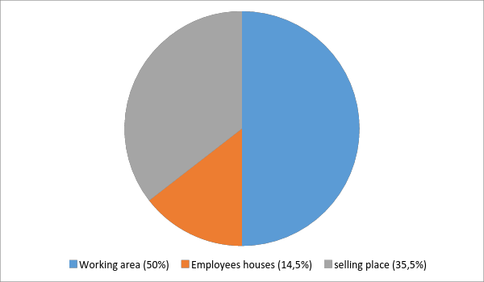

S.W.O.T Analysis of AMANGO:

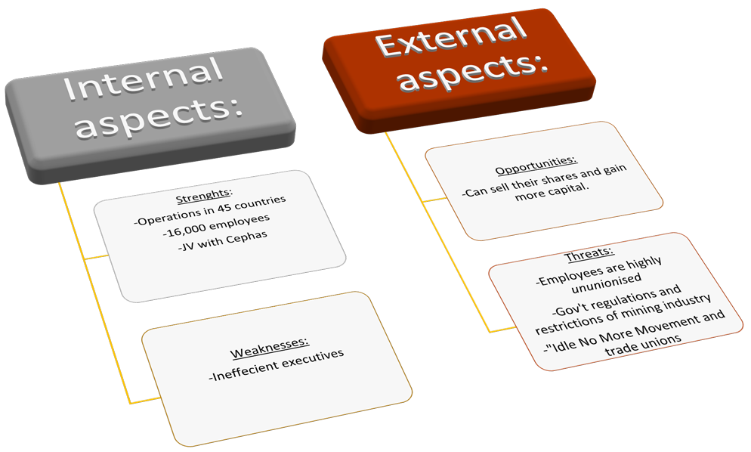

==========================THE END==========================

